**LAB NO 3 IMPROVED WEB DESIGN USING CSS/BOOTSTRAP**



**Spring 2025**

**Database Management Lab**

Submitted by:

Name : **Naveed Ahmad**

Reg no**. : 22PWCSE2165**

ClassSection **: B**

Submitted to:

**Engr. Summayea Salahuddin**

March 13, 2025

Department of Computer Systems Engineering

University of Engineering and Technology, Peshawar

**LAB NO 3 IMPROVED WEB DESIGN USING CSS/BOOTSTRAP**

**LAB PERFORMANCE:**

**Read the provided lab document carefully, prepare your lab report during the lab and submit it to your lab instructor during lab timing. (10 Marks)**

**Practical 1: Understand and go through all the 8 examples provided in this lab. Try each one in your favorite IDE. Check the output in browser. In your lab report, write comment about each example you have covered in your own words with that example output. (6 Marks)**

**Example 1**



**Output:** This example demonstrates font styling using CSS, including font family, size, style, and weight.

**Example 2**

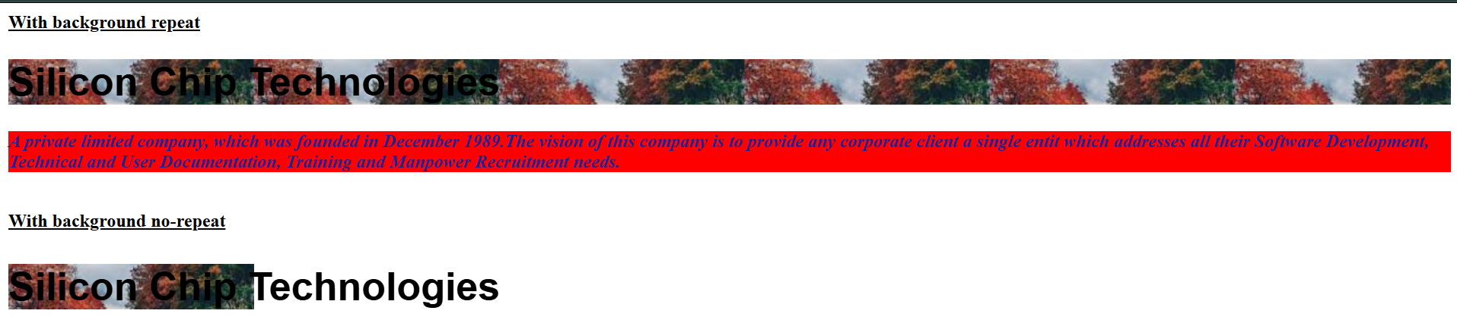

**Output:** This example demonstrates the use of text color and background color and background repeat.

**Example 3**

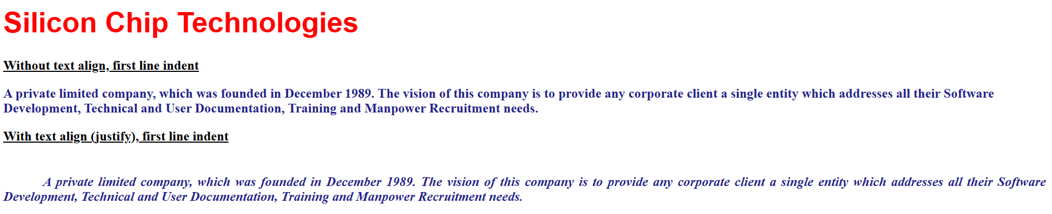

**Output:** This example shows a heading with underlined text and a paragraphs to show with indentation

**Example 4**

**Output:** This example shows a paragraph with padding from top and the content of the paragraph is indented.

**Example 5**

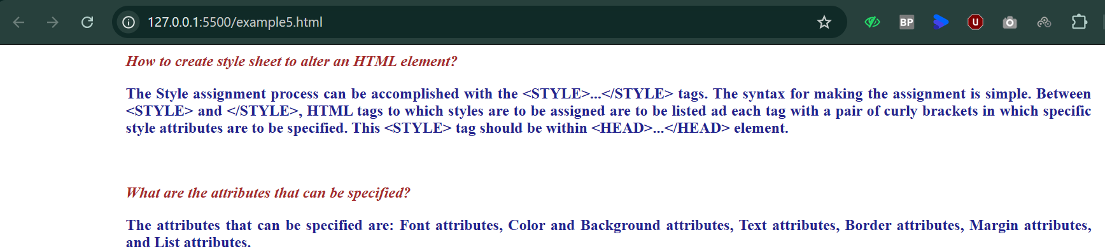

**Output:** This example shows the content indented from left using margins and a question appears in brown, and an answer appears in blue colour showcasing the use of colours.

**Example 6**

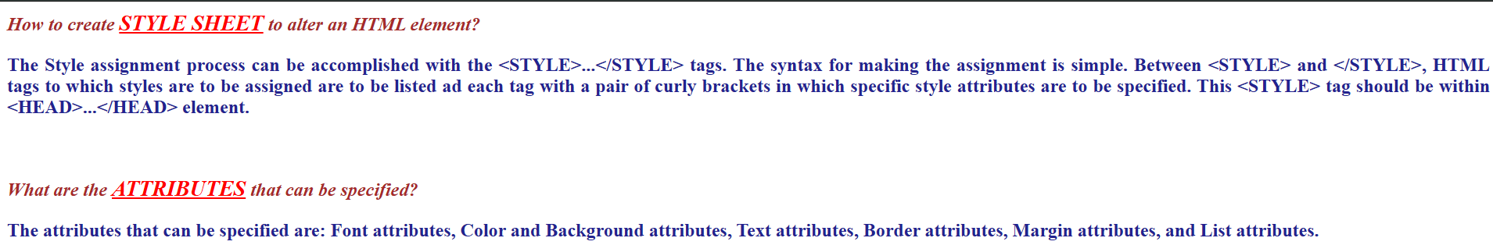

**Output:** The example shows the working with span element.

**Example 7**

**Output:** The example show a paragraph with justified content, bold italic and also another paragraph inside a bordered box.

**Example 8**

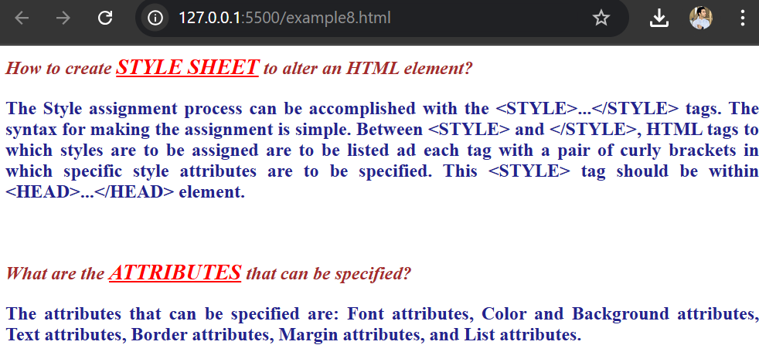

**Output:** The example show how to styling applied to the Html file with external styling CSS file applied.

**Practical 2: Write the HTML code with CSS that generates the web page shown in Figure 3.8 with following specification:**

* **Heading 1 has font value of Arial and Helvetica, size 26 pts, and red color.**
* **Each paragraph is 12 pts, bold, and italic. Take paragraph color value: #23238e**
* **Use groove border style and thick border width.**

**For reference, go to Table 4.4 for further details about the border attributes. Provide the HTML and CSS codes in your lab report. (4 Marks)**

**Code:**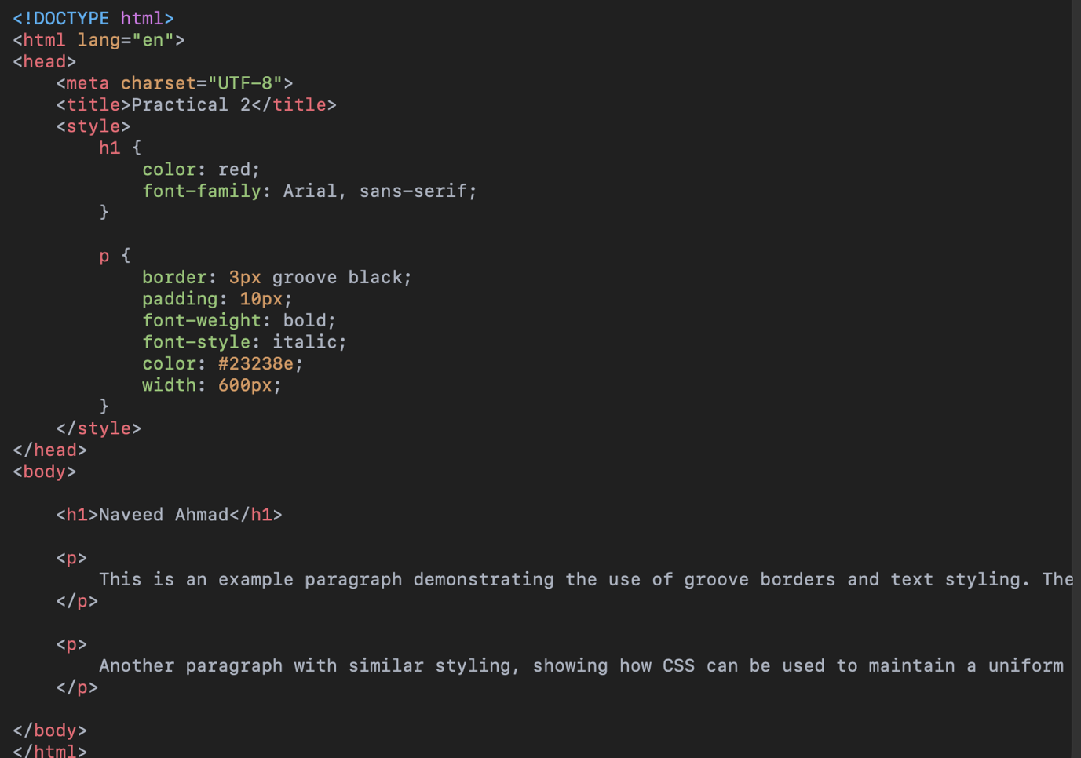

**Output:**

**Task 3.2**

**Homework 1:**

**Write the HTML code with CSS that generates the web page shown in Figure 3.9 with following specification:**

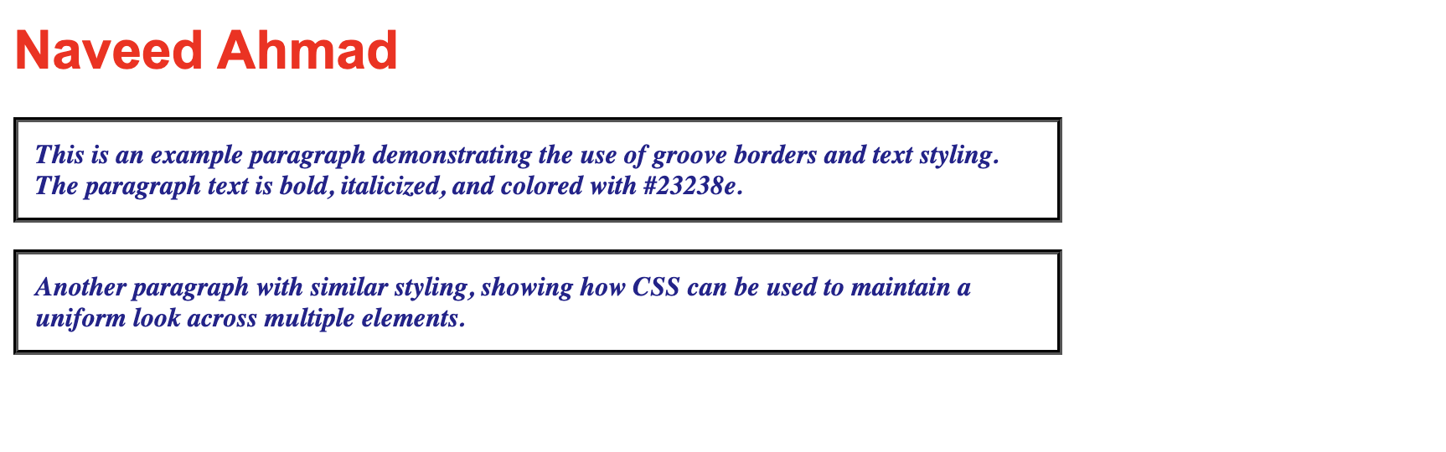

1. **Heading 1 has font value of Garamond, size 26 pts, and red color.**
2. **Set top margin to 5%.**
3. **Create unordered list with values: HTML, JavaScript, CGI, Java, Oracle Developer 2000, and Oracle DBA. Use square list style type.**

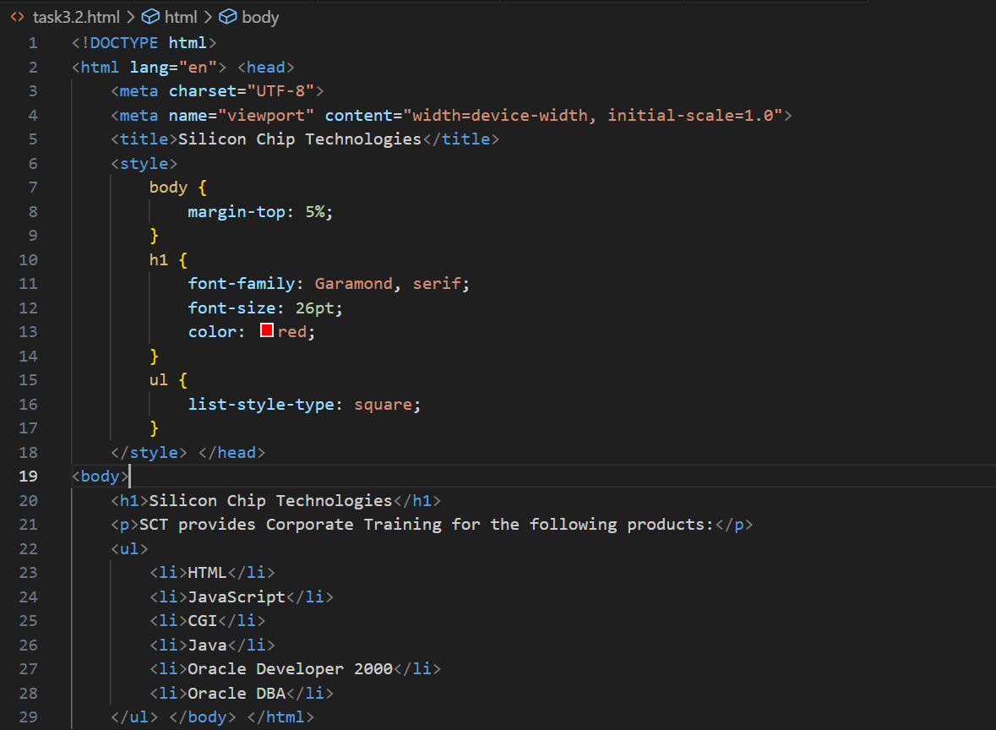

**Task 3.3**

**Homework 2:**

**Write the HTML code along with CSS file that generates the output web page shown in Figure 3.9.**

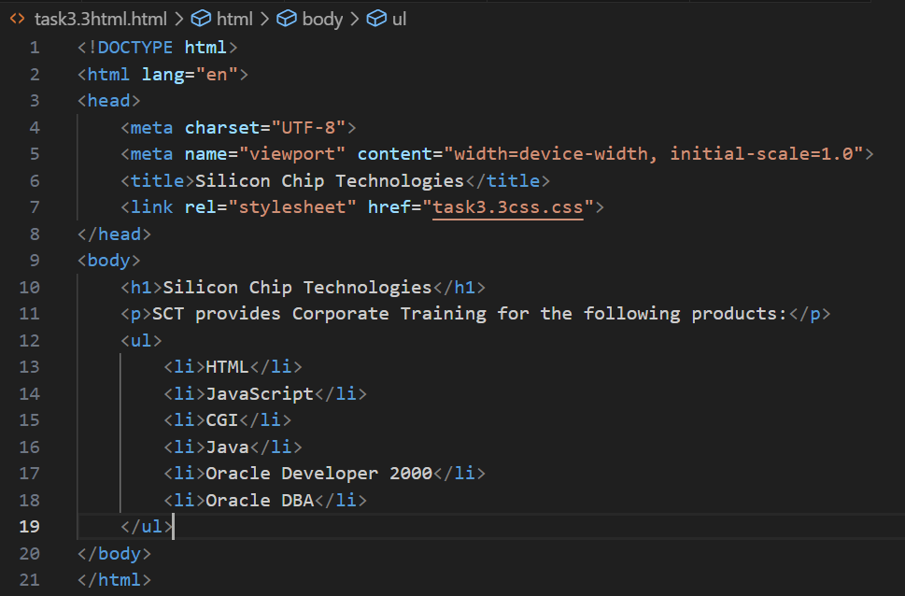

**Task 3.4**

**Homework 3:**

**Rewrite Example 5 using ID Selector instead of class Selector and show its output.**

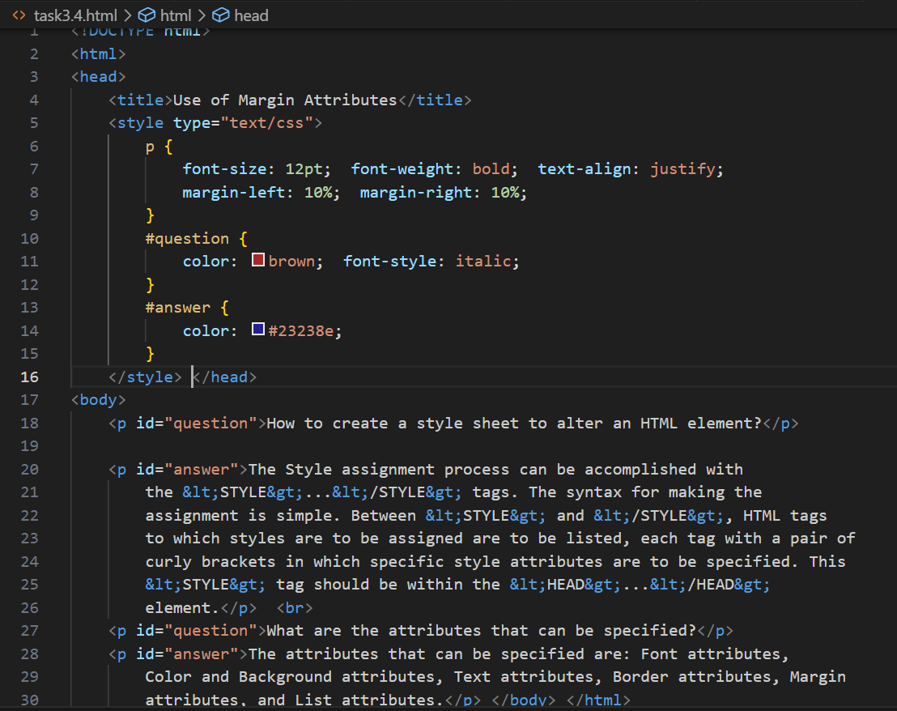

**Task 3.5**

**Homework 4:**

**Bootstrap 5.2.3 Examples: Go through the following examples in bootstrap-5.2.3-examples.zip: sign-in, cover, checkout, and blog. Modify these examples for a real-world application. Submit the modified web pages and respective HTML and CSS files with description.**

**Link to the real-world application website:**

[**https://healthcarenomii.netlify.app/**](https://healthcarenomii.netlify.app/)

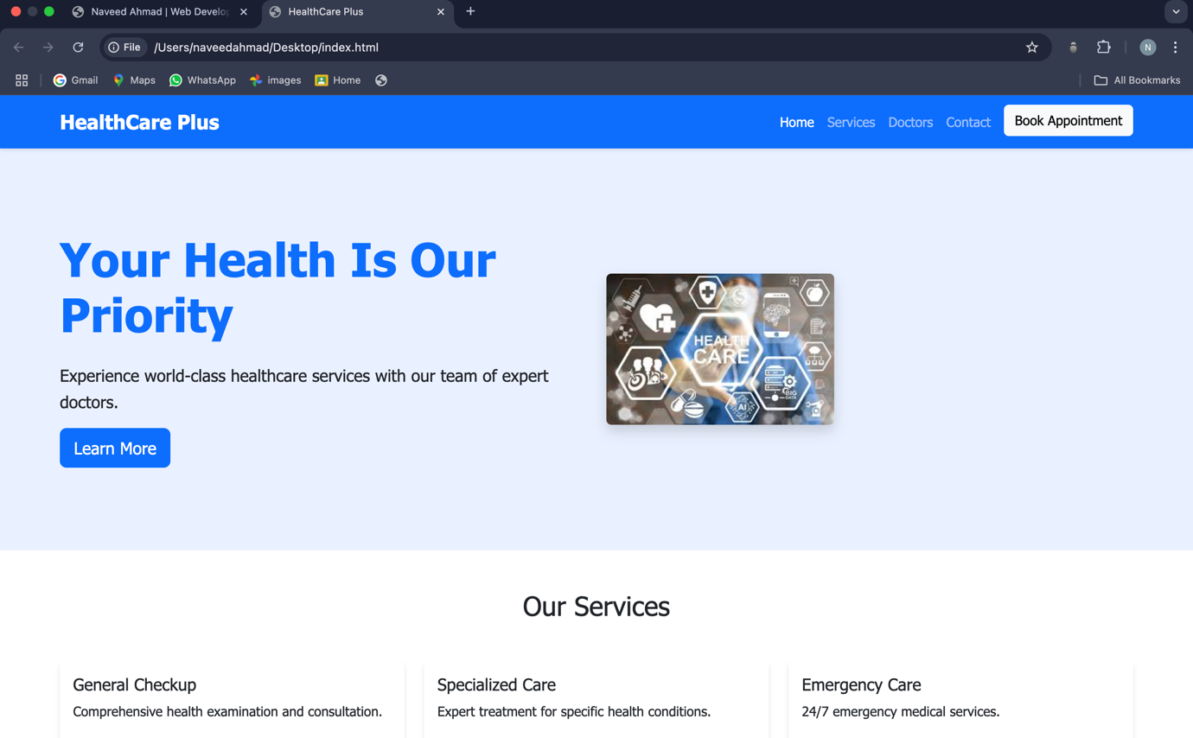

**Task 3.6**

**Homework 5:**

**Modify your CV designed using plain HTML in lab 02 by adding the CSS and Bootstrap in it. Upload both original one and modified one on the hosting site. Provide the link.**

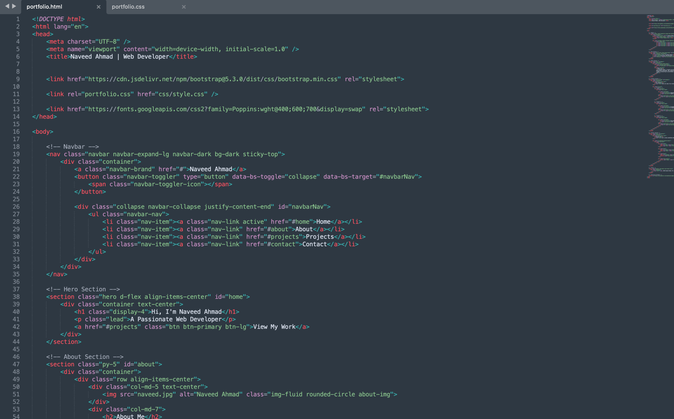

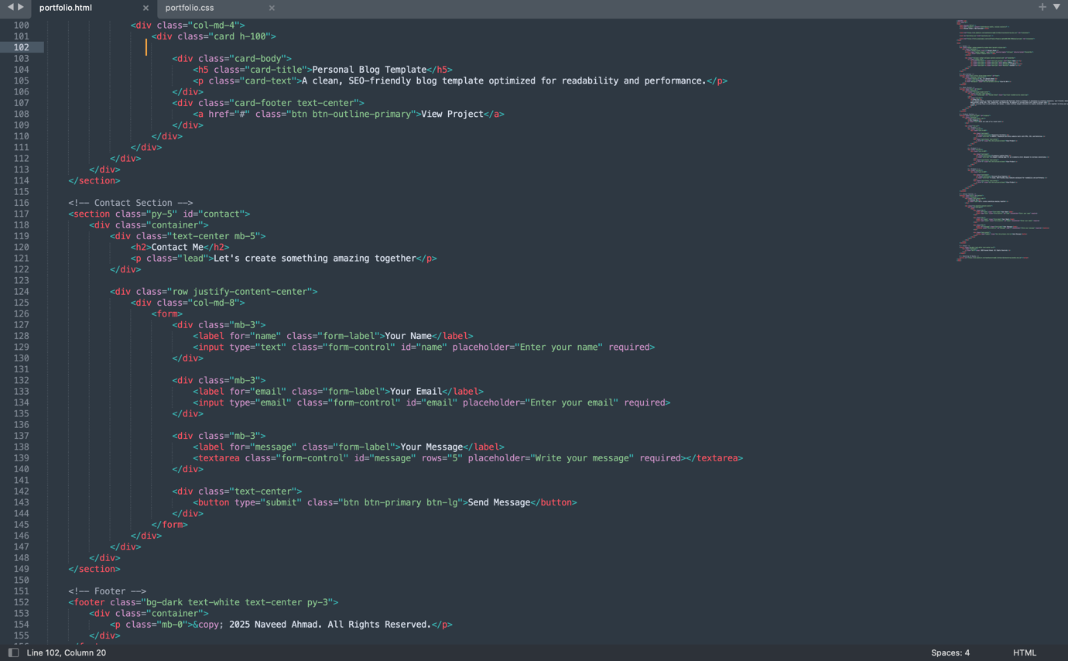

**Output Portfolio Website:**

